Bowie-Austin FFA Sheep/Goat Handbook
Number 1 Requirement: Pass all classes!
No pass=no play
UIL RULES
Requirements: Attend FFA Meetings, Attend Sheep/Goat weekly practices with teacher, Student Member of FFA and in Agriculture class, Parent Member of Booster Club and Active Participation in all Fundraisers!!!!!!!

Introduction
Hello, my name is Amber Dickinson and I am the advisor for Lamb and Goats at Bowie High School. This handbook will help guide students through the process of getting a lamb or goat. All must be read and signed before students shall get an animal. This is the student’s project not the parent or teacher, so the student will be responsible for knowing all information.

Cost Breakdown
Animal- $500-750+ (prices are subject to change- will have to make a decision on what your budget is)
Initial Costs- $100+- Items will be listed below that you need to acquire
Pen Fee- $50
Wormer- $10 (will purchase for everyone and have set dates to worm each month)
Validation Fee- $18~
TCYS Fee- ~$20 per animals
Major Show fees $30+
Feed Costs- Depends on Feed (average $50 a month) and hay
Vet Bills- As needed- Ag teacher is not a licensed vet so if a diagnosis will need to take to a vet

Getting the animal- June and July
Mrs. Dickinson will be going one time in June for sheep and goats and one time in July for sheep and goats- if those do not work with you then you will be on your own to get your own animal

Resources-
Lamb- http://animalscience.tamu.edu/wp-content/uploads/sites/14/2012/04/AS34059-showlamb.pdf
https://texasyouthlivestock.com/wp-content/uploads/2013/11/Explore_SheepGoat.pdf
https://www.youtube.com/watch?v=vSu67BCROxk
https://www.youtube.com/watch?v=xsjgm-lduh0

Goat-https://texasyouthlivestock.com/wp-content/uploads/2013/11/AS34060-meatgoatguide.pdf
https://www.youtube.com/watch?v=YnkdAQXtlCE

Equipment Needed- Pictures are just examples

Feed bucket- hanging bucket
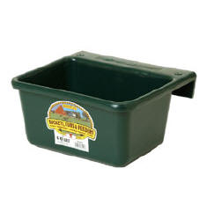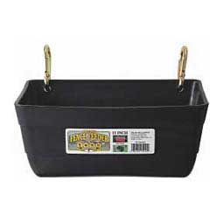
Water Bucket- Large bucket either the one you can hang on fence or on the ground
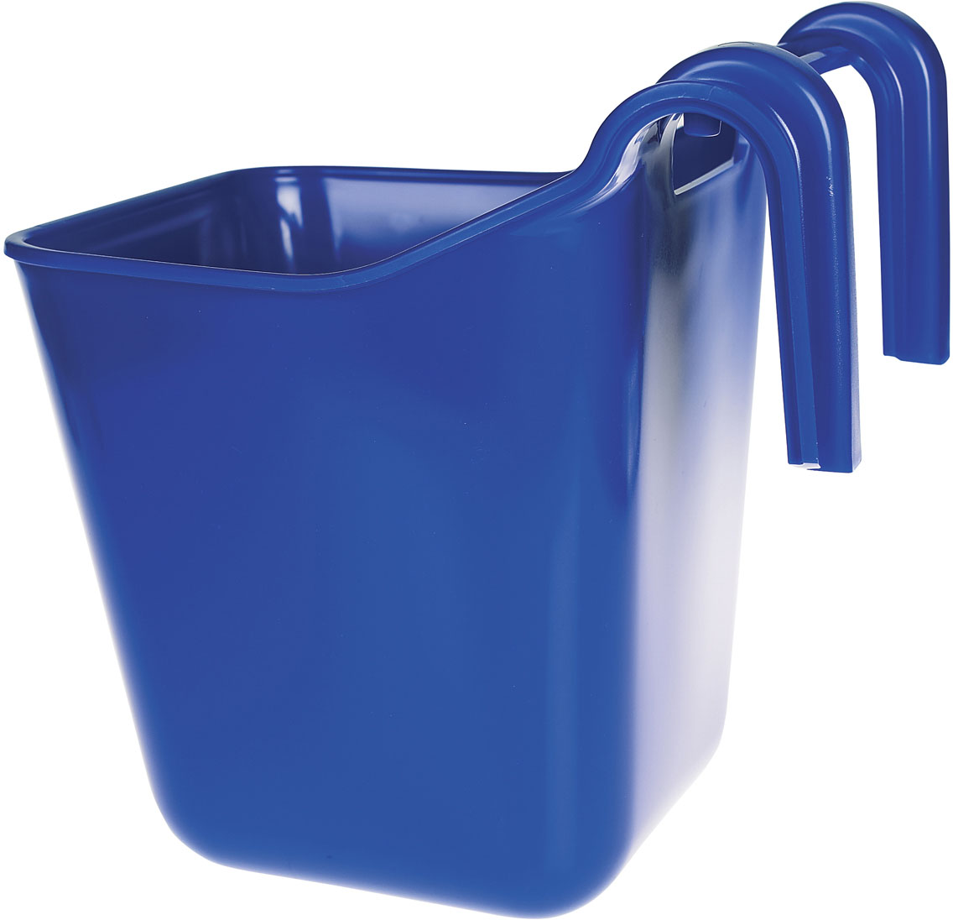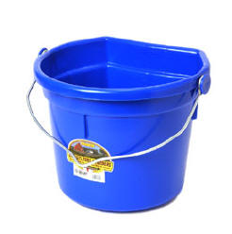
Halter
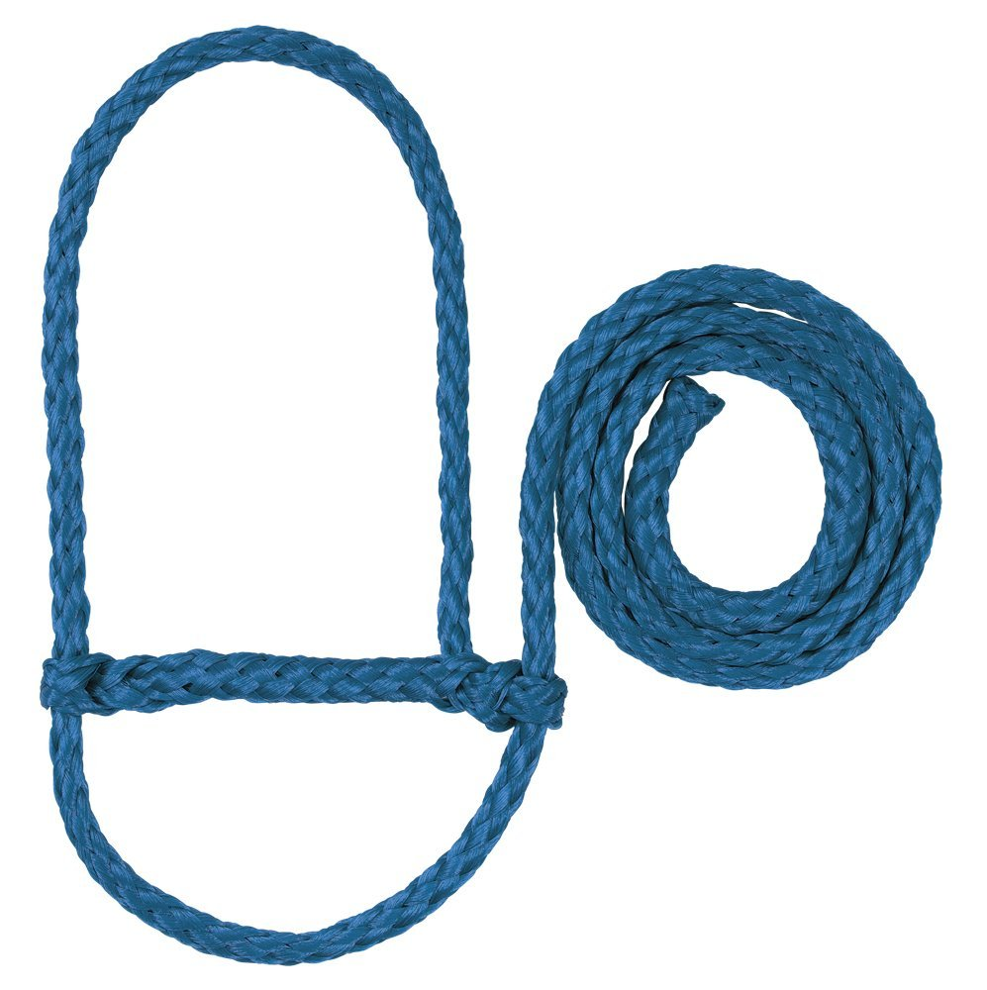
Goats- chain
Blanket/sock- cooler weather or cool blanket for keeping off of the sun
Drench gun
Hoof trimmer
Trash container or some type of container for keeping supplies/food in
All hay will be required to be put in a container as well
Shade cloth for the pins- want to keep sheep/goats cool
Fan- for summer heat

Validation and Tagging-
This will be done in October and is required to show any county or major shows. Transportation of the animal to the validation site will be done as a group.

Requirements
Weekly Practices- Everyone will be expected (not mandatory) to attend weekly practices days will be set up once a week- if student is not able to attend any practices then there can be no complaints about not getting any help!!!!!!
Monthly Sheep/goat clinic- I will set up once a month for a clinic for both species either held by Mrs. Dickinson or some outside individual- this will be a required event
FFA Grades- You are required to keep a record of everything that you do with the animal in form of recordbook. This is an SAE project and requires accurate records. Please keep all receipts and journal activities you are doing at the farm. There is a grade for SAE projects in every class so your grade will reflect your time and effort into your project.
School Grades- You are responsible for taking care of your school grades, those that do not pass their classes do not get to attend any shows. NO PASS= NO PLAY, you get UIL excused so we follow all UIL rules. It is not Mrs. Dickinson’s responsibility to make sure you are passing, it is the students. Grade checks will be done before any UIL excused event.

Barn Requirements-
You are required to keep the barn looking nice so every week Lamb and Goat students need to make sure that all trash is taken to the dumpster. All wheel barrels and racks/shovels are put back in proper location after each use!!! You must be cleaning out your pen at minimum weekly. Your pen needs to be cleaned out as soon as your animal leaves at the end of the year and will be checked by the Ag teacher. Those that do not clean up will not show and seniors will not walk the stage until this is taken care of. The farm is a privilege for you to have and if you cannot do your part in maintaining it then you will not be allowed to show with the program anymore.

Livestock Shows
- Required- TCYS- this is just a county show so you can take animal back after
- Jackpot/ Prospect Shows- Will post them on the FFA website when receive them- Only one that teachers will attend is Clifton all others will be on your own.
- Optional Terminal Shows- (Meaning you do not get to take your animal home with you after)
  - San Antonio- Mrs. Dickinson will be transporting animals only to this major show
  - Fort Worth
  - Houston
  - Rodeo Austin
  - San Angelo
Dates will be posted as soon as I receive them. If you go to a major show other than San Antonio you are on your own as far as transportation. Teachers only get 10 days each for livestock so they do not have the ability to go to all shows.

Supply from J&B feeds- they will keep what we need in stock as long as we purchase from them
Callahan's and Tractor Supply are other locations

Feed
- We will talk to breeder about their recommendation
- Lambs from Dickinson need to feed Highnoon 18% (unless we purchase from another breeder)
- Some great feeds- there are many but we will get the recommendation from the breeder
  - Jacoby’s (goats have been using this type of feed)
  - Purina Show Chow
  - Show-Rite
  - Moor-Mens
- Minerals
- Haygrazer for lambs and Alfalfa for goats (small amount)

Wormer- will need to worm every 30 days- change up the type

Vet- In case of emergency or sickness

Commitment
- Feed twice daily- morning around 7:30 am and evening 6:00 pm- feed after working with animal in the evening (as a reward for doing what you asked of them)
- Clean pin every other day
- Keep water fresh daily
- Work with at least 30 minutes to 1 hour or more daily (Will not just feed when going to the barn, need to work with animal as well)
- Students will all attend TCYS in January. Mrs. Dickinson will be going to San Antonio but if students want to go to other major shows they will be on their own.
- If you go out of town the animal will still need to be fed- will need to find another responsible show animal student to do so. Please though once you get the animal do not make a habit of leaving all the time- you only have the animal for so many months and every moment working with them counts to get them ready. (Going out of town for more than a couple days could harm the quality of your project- animals get attached to those feeding and this can cause them to not eat if you are not the one feeding).

Outline of Commitment with Animal

First Week or Two- Depending on animal
- Sit in pin with animal at least 30 minutes a day to get them used to you- 30 minutes in the morning and 30 minutes at night feeding- recommended

Week Two or Three- once they allow you to handle them- this will continue the rest of time with animal
- Start with halter- getting them used to it
- Tie them up starting with 5 to 10 minutes work up to an hour. We want them to have endurance to do what we want from them specifically for show, may be in the ring for 45 minutes up.
- Once they are used to halter- walk daily- start with smaller time 10 minutes work on up to 45 minutes plus
- Also if they allow you start working with feet while they are tied up. Will work on feet position for showing (Mrs. Dickinson can show you proper placement).

Goats- after halter broken start working on chain breaking

Driving- once you get the animal to where you can set up their feet with being tied up we can start working on this. Ask Mrs. Dickinson, when you get to this point.

Exercise- Should be walking every day but about 2 to 3 months before show we will start with short burst of high intensity workout- treadmill/track.

Feed Additives/Supplements close to show
Drench- start few weeks before show (Mrs. Dickinson will give recommendations closer to show)
Have routine @ TCYS and San Antonio (other shows on your own)

Shear before show- new students can get help from Mrs. Dickinson or other students who have experience

Goats- some may have to be dehorned- will need to do as soon as you can months before show- allow for proper healing

Hoof- trimmed when too long
Want to do 1 to 2 weeks out before show in case you may cut too short will allow for growth

Worm Regularly- want to make sure they are not sick, will need to change up which wormer used to help with resistance

Other things to think about-
Weight animal to see growth- can help with adjusting the amount of food needed- Weekly- same time each week

