Bowie-Austin FFA Pig Handbook
Number 1 Requirement: Pass all classes!
No pass=no play
UIL RULES
Requirements: Attend FFA Meetings, Attend Pig Clinics, Student Member of FFA and in Agriculture class, Parent Member of Booster Club and Active Participation in all Fundraisers!!!!!!!

Introduction
Hello, my name is Amber Dickinson and I am the advisor for Pigs at Bowie High School. This handbook will help guide students through the process of getting a pig. All must be read and signed before students shall get an animal. This is the student’s project not the parent or teacher, so the student will be responsible for knowing all information.

Cost Breakdown
Animal- $500-750+ (prices are subject to change- will have to make a decision on what your budget is)
Initial Costs- $100+- Items will be listed below that you need to acquire
Pen Fee- $75 (Paid to booster club)
Wormer- $10 a month depends on wormer purchased
Validation Fee- $20
TCYS Fee- $20 per animals
Major Show fees $30+
Feed Costs- Depends on feed but I would say average $100 a month
Vet Bills- As needed- Ag teacher is not a licensed vet so if need diagnosis will need to take to a vet

Getting the animal- September October

Before getting animal- Tour of facility with parent and student

Equipment Needed- Pictures are just examples

Feed bucket (something you can hang on the fence)
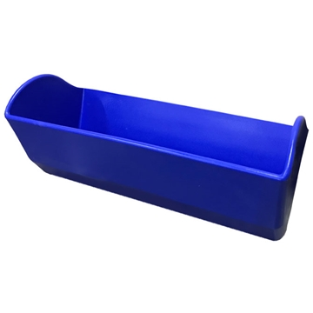
Shade cloth
Pig whip/pipe
Brush
Hay (in the winter when it gets cold but not before)
Container to put feed in (like a metal trash can)
Oil (Will depend on if you get a light or dark pig what type you need to get)
Might want to purchase a portable pig waterer (sometimes there are troubles at the farm with the water system)- also can use at show
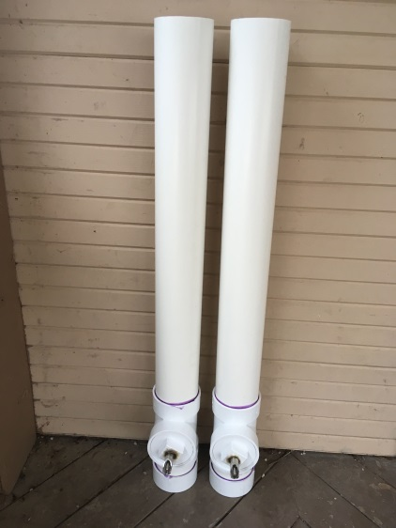

Validation and Tagging-
This will be done in November and is required to show any county or major shows. Validation for pigs is at Bowie High School.

Requirements
Weekly Practices/Pig Church- Everyone will be expected (not mandatory) to attend weekly practices days will be set up once a week- if student is not able to attend any practices then there can be no complaints about not getting any help!!!!!!
FFA Grades- You are required to keep a record of everything that you do with the animal in form of recordbook. This is an SAE project and requires accurate records. Please keep all receipts and journal activities you are doing at the farm. There is a grade for SAE projects in every class so your grade will reflect your time and effort into your project.
School Grades- You are responsible for taking care of your school grades, those that do not pass their classes do not get to attend any shows. NO PASS= NO PLAY, you get UIL excused so we follow all UIL rules. It is not Mrs. Dickinson’s responsibility to make sure you are passing, it is the students. Grade checks will be done before any UIL excused event.

Barn Requirements-
You are required to keep the barn looking nice so every week pig students need to make sure that all trash is taken to the dumpster. All wheel barrels and racks/shovels are put back in proper location after each use!!! You must be cleaning out your pen at minimum every other day. Best if you are cleaning every day. Your pen needs to be cleaned out as soon as your animal leaves at the end of the year and will be checked by the Ag teacher. Those that do not clean up will not show and seniors will not walk the stage until this is taken care of. The farm is a privilege for you to have and if you cannot do your part in maintaining it then you will not be allowed to show with the program anymore.

Livestock Shows
- Winterfest/Chapter Show December
- Required- TCYS- this is just a county show so you can take animal back after- January
- Optional Terminal Shows- (Meaning you do not get to take your animal home with you after)
  - San Antonio- Mrs. Dickinson will be transporting animals only to this major show if there are enough interests- Feb
  - Fort Worth- Jan
  - Houston- March
  - Rodeo Austin- March
  - San Angelo- Feb
Dates will be posted as soon as I receive them. If you go to a major show other than San Antonio you are on your own as far as transportation. Teachers only get 15 days each for all FFA activities so they do not have the ability to go to all shows.

Supply from J&B feeds- they will keep what we need in stock as long as we purchase from them
Callahan's and Tractor Supply are other locations

Feed
- We will talk to breeder about their recommendation

Wormer- will need to worm every 30 days- change up the type

Vet- In case of emergency or sickness

Commitment
- Feed twice daily- morning around 7:30 am and evening 6:00 pm (same time every day)- feed after working with animal in the evening (as a reward for doing what you asked of them)
- Clean pin every day
- Make sure the water is working in your pen
- Work with at least 30 minutes to 1 hour or more daily (Will not just feed when going to the barn, need to work with animal as well)
- Students will all attend TCYS in January. Mrs. Dickinson will be going to San Antonio but if students want to go to other major shows they will be on their own.
- If you go out of town the animal will still need to be fed- will need to find another responsible show animal student to do so. Please though once you get the animal do not make a habit of leaving all the time- you only have the animal for so many months and every moment working with them counts to get them ready. (Going out of town for more than a couple days could harm the quality of your project- animals get attached to those feeding and this can cause them to not eat if you are not the one feeding).

