Show Rabbit Info

Here are some supplies you will need and tips for rabbit care. Rabbits are tricky projects to do, but can be very fun!

You will need to keep your rabbits in separate cages and away from each other. The only exception being the first week in which you will need to keep them together until they get used to their new environment.

An important note, If you have the rabbits in hanging cages DO NOT scoop the poop that falls out. This will stir up dust and cause respiratory problems with your rabbits.

Other than feeding and watering rabbits every day, we will have weigh dates, in which we will track the rabbits growth. Students will also need to “work the rabbits fur” This is as simple as putting water on your hands and rubbing through the rabbits fur (which I will demo when we get the rabbits). You may also put a PVC pipe in between the water bottle and feeder to get the rabbits to hop over.

Feed:

Here are a few options:

Petrus Elite Best In Show 780 (found at producers coop in seguin)
Bluebonnet feed 16%

Coastal or Timothy Hay, you will feed a little under a handful

You may also feed an Electrolyte Mix:
    - 4 part crimped oats
    - 2 part whole oat
    - 2pt crimped Barley
    - ½ Part Black oil Sunflower Seeds
**If you feed the electrolyte mix please do so in a separate bowl and feed in the mornings, 1tsp

Supplies:

Wire bottom transport cages
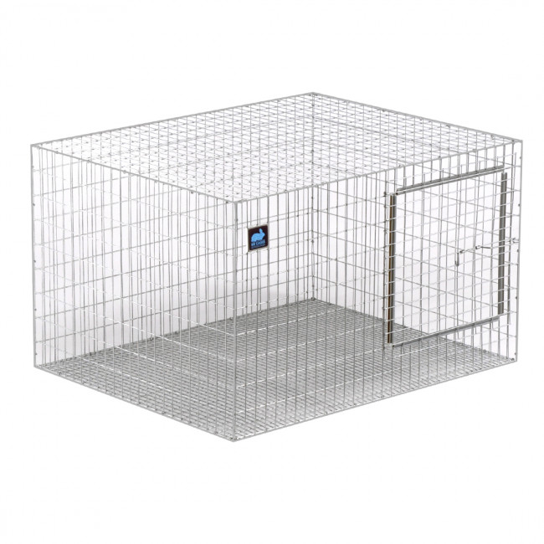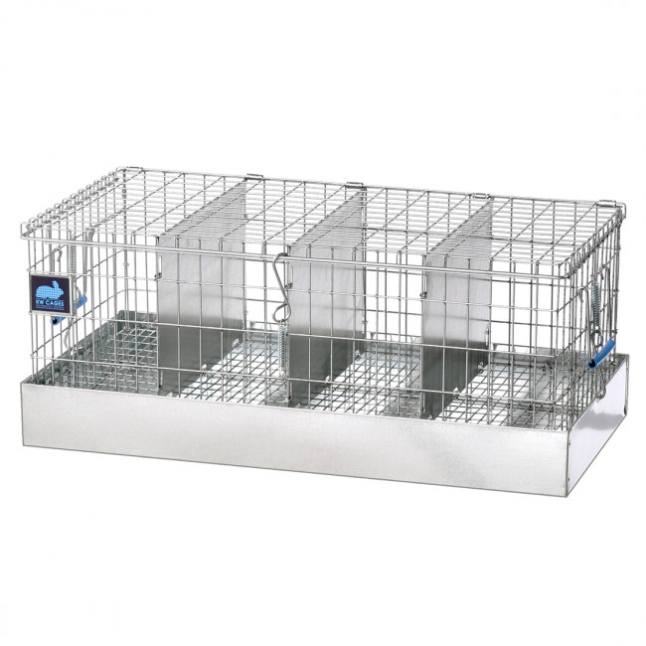

Rabbit water bottle for each rabbit
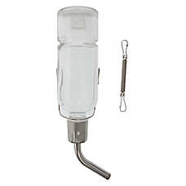

Rabbit feeder for each rabbit:
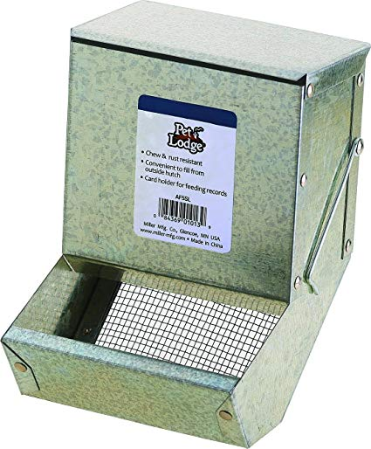
Rubbermaid buckets of some kind to catch the droppings- While we have the rabbits please DO NOT scoop the poop! The dust will irritate the rabbits. Please place the buckets under the cages to collect dropping for removal after show.
