Show Turkey Guide

Please email me with any questions at shelby.stephens@austinisd.org

Pick up time for the chicks is still TBD, but will likely be the first or second week of November. As soon as I have the pick up date I will let you know. I will bring them to the school so that I can validate the band numbers. STUDENTS MUST BE AT THE FARM TO MEET ME FOR THE VALIDATION AND GET THEIR TURKEYS. THIS IS MANDATORY!!! I highly recommend that for the first two weeks you keep the chicks at home, in a climate controlled area. Poultry need to be kept at 72 degrees. After you can bring them to the school and put them in the pens. This is not required but highly recommended.

***PENS MUST BE CLEANED DAILY

Be prepared to cull out birds as they grow. Please keep culled birds away from show birds if you choose to feed them out. I will set up times I will be available to cull birds with students. Make sure you are taking advantage of these culling times, and do not attempt to cull birds on your own.

Feeds:

Turkey Starter 32% Medicated -
This is what we will start with, then move on to

Chicken (or Turkey Feed) 28% Medicated OR Chicken (or turkey feed) 26% Medicated
***I will advise based on flock growth and # of cull chickens****

As we get closer to show We will either drop or increase protein based on turkey growth.

Be prepared to also feed your bird:
Corn Chops (combo of equal parts cracked corn, butter, and WHOLE milk)
Hard Boiled Eggs ( You will need a lot of eggs! Number of eggs based on flock size)

**Please note that the birds may not eat all the extras at first, please keep giving it to them until they learn to eat it!

Citrilyte- J&Bs should be carrying this in the next week or so! This will go in the water- follow instructions on packet

As your flock grows, please know that I will make suggestions for additional supplies as needed

Turkey Supplies

Pine Shavings- (these will be put down as bedding for the chicks as well as when we move the birds into the pens, please do not put them in your pens until you are putting in your chicks!
http://jnbfeednhayaustin.com/?s=shavings

Trash Can- metal to keep the feed in

Feed Scoop

Hand Sanitizer

Feed pans-This is what we will use to feed the birds, in addition to the hanging containers as the birds get older. As they grow you will need to get several empty milk jugs- we will hang them from the ceiling and that is what we will feed the older birds with in addition to the feed pans. (I will show the kids how to get this set up in the pens- I know it sounds odd)!

Chicken Waterers- You will also use feed pans and milk jugs to provide water along with these. Remember chickens need water to grow, you will need SEVERAL of these more so with a larger flock

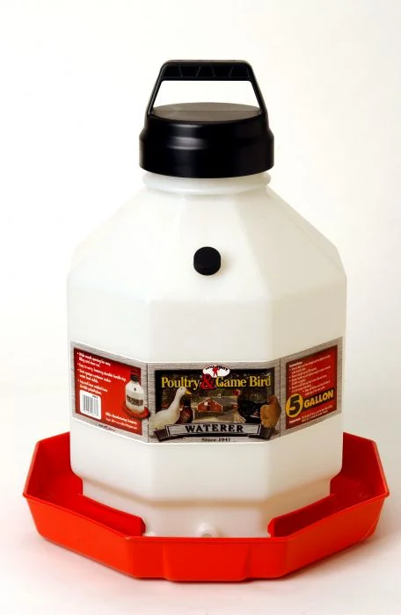

Tarps- THIS IS MANDATORY. Students will need clear tarps to put up around the pen so the birds stay nice and warm. Tarps will need to be put up around the entire pen and door, to help keep in heat.

Heat lamps- Heat lamps have a tendency to walk off, please put your name on the ones you buy! Limit yourself to 1-2 lamps per pen, as more than this will blow farm fuses.

